PREMIUM CLOTH COLLECTION
Clothing Catalogue — 2026 Collection
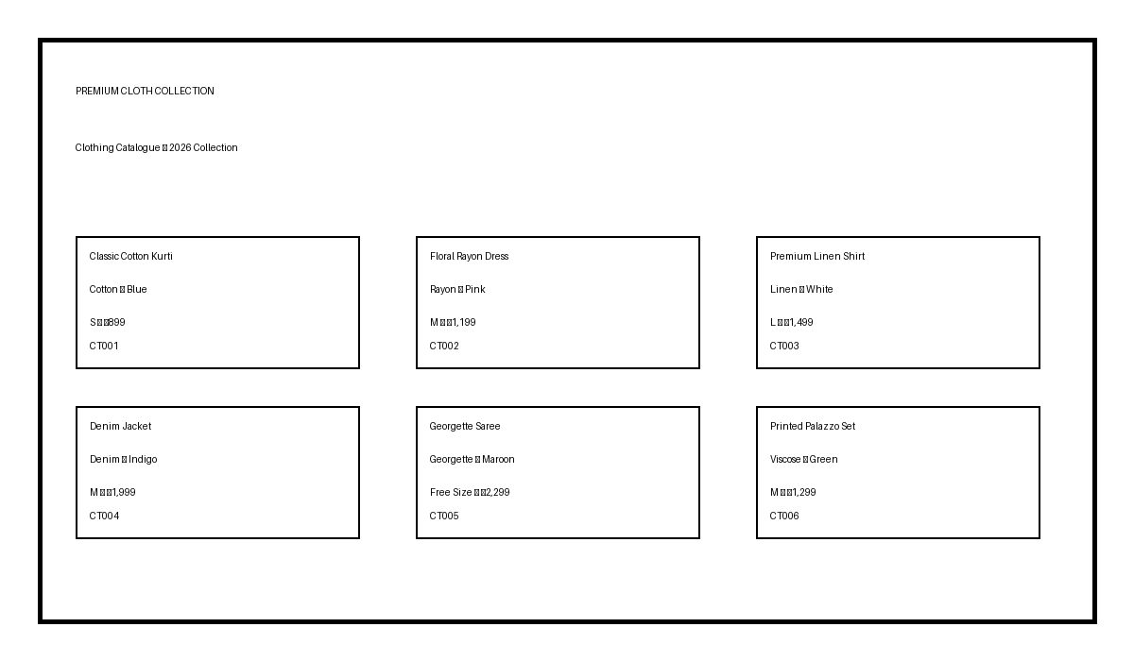
Code | Product | Fabric | Colour | Size | Price
CT001 | Classic Cotton Kurti | Cotton | Blue | S | ₹899
CT002 | Floral Rayon Dress | Rayon | Pink | M | ₹1,199
CT003 | Premium Linen Shirt | Linen | White | L | ₹1,499
CT004 | Denim Jacket | Denim | Indigo | M | ₹1,999
CT005 | Georgette Saree | Georgette | Maroon | Free Size | ₹2,299
CT006 | Printed Palazzo Set | Viscose | Green | M | ₹1,299
CT007 | Casual Polo T-Shirt | Cotton | Black | L | ₹699
CT008 | Embroidered Anarkali | Cotton Blend | Peach | L | ₹1,799
CT009 | Straight Fit Trousers | Poly-Cotton | Beige | M | ₹999
CT010 | Party Wear Gown | Net | Wine | Free Size | ₹2,499
Catalogue includes product codes, fabric, colour, available size and price.

